Ques 7: Write a program to find and display the upper triangle in a matrix if it exists.

**Algorithm :-**

**Code :-**

//program to check upper triangular matrix

#include<bits/stdc++.h>

using namespace std;

int main ()

{

int a[10][10],i,j,m,n,flag=0;

clock_t start,end;

//m and n are the rows and columns of matrix A respectively.

cout<<"Enter no. of rows of matrix A: ";

cin>>m;

cout<<"Enter no. of columns of matrix A: ";

cin>>n;

cout<<"\nEnter elements of matrix A:\n";

for(i=0;i<m;i++)

{

for(j=0;j<n;j++)

{

cin>>a[i][j];

}

}

start=clock();

cout<<"\nMatrix A:\n";

for(i=0;i<m;i++)

{

for(j=0;j<n;j++)

{

cout<<a[i][j]<<"\t";

}

cout<<endl;

}

//checking square matrix

if(m==n)

{

for(i=0;i<m;i++)

{

for(j=0;j<m;j++)

{

//checking lower triangle elements are zero

if(i>j)

{

if(a[i][j]!=0)

{

flag++;

break;

}

}

}

}

}

else

cout<<"\nUpper triangular matrix cannot be checked.";

if(flag==0)

cout<<"\nMatrix A is upper triangular matrix";

else

cout<<"\n Matrix A is not an upper triangular matrix";

end=clock();

double time_taken = double(end - start) / double(CLOCKS_PER_SEC);

cout <<"\nTime taken by program is : ";

cout<< fixed <<time_taken<<setprecision(5);

cout <<" sec "<< endl;

}

**Output** :-

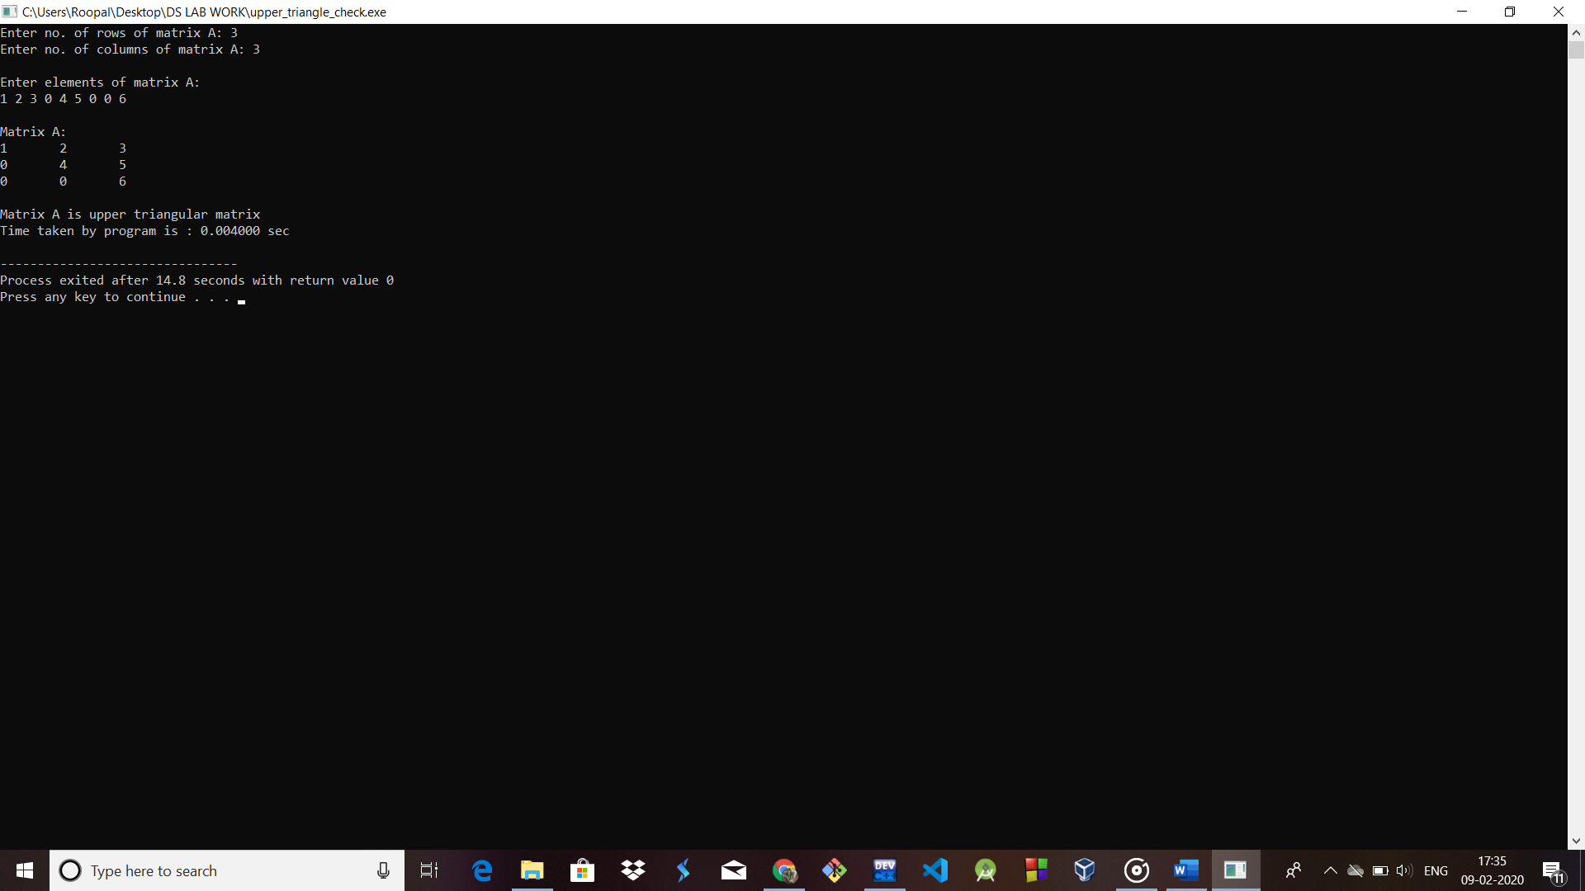

Ques 8: Write a program to check whether two matrices are symmetric or not.

**Algorithm :-**

**Code :-**

//program to check symmetric matrix

#include<bits/stdc++.h>

using namespace std;

int main ()

{

int a[10][10],i,j,m,n,flag=0;

clock_t start,end;

//m and n are the rows and columns of matrix A respectively.

cout<<"Enter no. of rows of matrix A: ";

cin>>m;

cout<<"Enter no. of columns of matrix A: ";

cin>>n;

cout<<"\nEnter elements of matrix A:\n";

for(i=0;i<m;i++)

{

for(j=0;j<n;j++)

{

cin>>a[i][j];

}

}

start=clock();

cout<<"\nMatrix A:\n";

for(i=0;i<m;i++)

{

for(j=0;j<n;j++)

{

cout<<a[i][j]<<"\t";

}

cout<<endl;

}

for(i=0;i<m;i++)

{

for(j=0;j<n;j++)

{

if(a[i][j]!=a[j][i])

flag++;

}

}

if(flag==0)

cout<<"A is a symmetric matrix";

else

cout<<"A is not a symmetric matrix";

}

**Output** :-

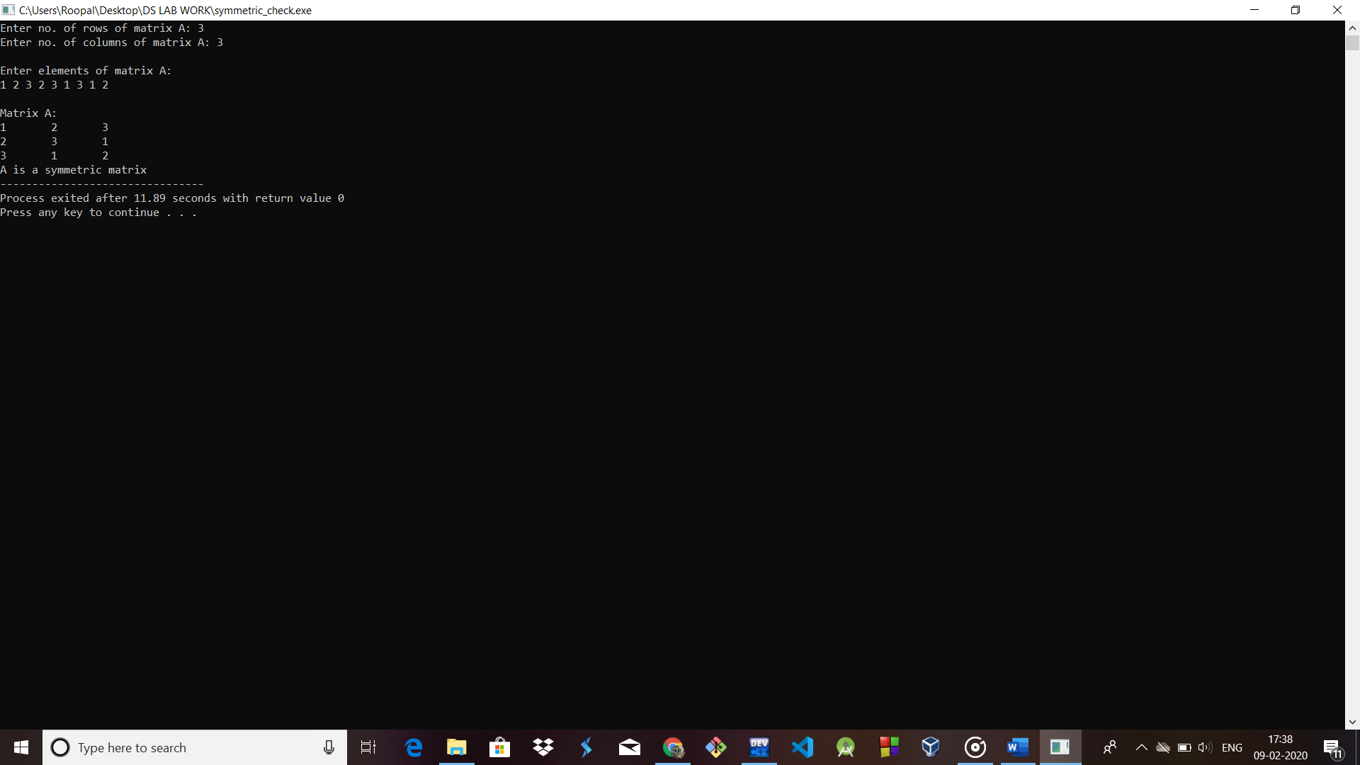

Ques 9: Write a program to multiply two sparse matrices where sparse matrices are represented by the following-

(a) Array

(b) Linked list

Ques 10: Write a program for implementing polynomials where user is going to enter expression in terms of ax^2 + b x + c and then find output and add and multiply the expression using-

(a) Sparse matrix

(b) Singly linked list

Ques 11: